**Curriculum Vitae**

**Personal Information**

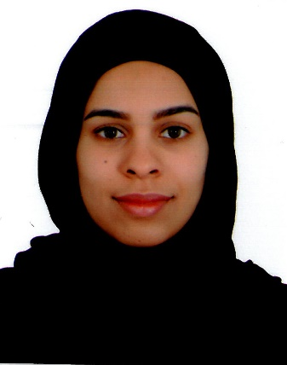**Name** Ejlal A.jalil Kadhem Ahmed

**Date of Birth** November 1991

**Nationality**

**Marital Status Contact No. Home Address**

**E-mail**

Bahraini

Married

33058229

H 1336 – R 1946 – B 419

Jidhafs. [Ejlal.91@hotmail.com](mailto:91@hotmail.com)

**Education**

**2017** University of Bahrain (UOB)- BSc Accounting – Management.

**2013** Bahrain Training institute (BTI) – National Diploma “Finance”.

**2009** Secondary Certificate - Isa Town Secondary Commercial Girl's School.

**Languages**

• **Arabic** Mother Tongue

• **English** Good

**Personal Skills**

• Familiar with Microsoft office (Word, Excel, Power Point).

• Good interpersonal & Communicational skills.

• Able to learn quickly and to share information with colleagues in an efficient manner.

• Able to work as part of a team efficiently.

• Organized, dedicated, confident, and ambitious.

• Have driving license.

**PROFESSIONAL QUALIFICATIONS (TRAINING):**

* Innovation Camp program
* Dealing with difficult personalities skills.
* Prepare your own business plan.
* Leadership program: The art of the others to develop.
* Protocol: the art of ceremony and the master of ceremonies.
* Self-confidence.
* NLP

**Training Skills:**

* Purchase department-UOB
* Practical Training department –UOB

**Interests and Hobbies**

Reading recent account evolutions and current issues, counting, watching movies, reading

Magazines, search on the net.